# SYSC3310 Project Bailey Lyster 101115419

Design of the Python Code:

Imports:

Serial was used for communication between the board and the PC, over ‘COM4’ at a Baudrate of 9600. 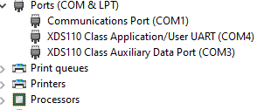

TKINTER was imported to created an easy GUI to interface with the board. TKINTER uses a main loop.

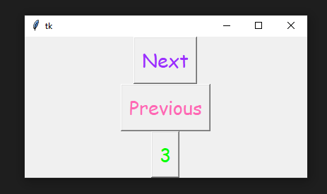

Threading was imported to create a secondary loop that could poll the COM port for any changes in the state, whether they are caused by the board’s buttons or the GUI’s

Embedded Code:

Code from UART Echo example and Lab 3 were repurposed for the embedded code. The initialisation of the PINS for the ECHO and LAB3 were re-used. The IRQ for both the UART and the Port1 buttons were written to trigger the newly generated functions incrementState and decrementState.

The state machine on the board was handled by new functions, incrementState and decrementState, they only permit the states to transition up or down the states, one state incrementation at a time. The LEDS are set by theses functions are cannot be altered by any other functions in the code, only a button on the gui or the board can alter the state.

|  |  |
| --- | --- |
| State 0 | Both OFF |
| State 1 | White ON |
| State 2 | RED ON |
| State 3 | BOTH ON |